**Introduction:**

**Java Language History?**Java was originally developed by James Gosling at Sun Microsystems (which has since been acquired by Oracle) and released in **1995** as a core component of Sun Microsystems' Java platform.

It started with version 1.0 and has a latest version of 15.

**How a Java Program runs?**

**

**Data Types and Variables in Java?**

Data type specifies the size and type of values that can be stored in an identifier.

Different types of Data Types in Java are described as below:

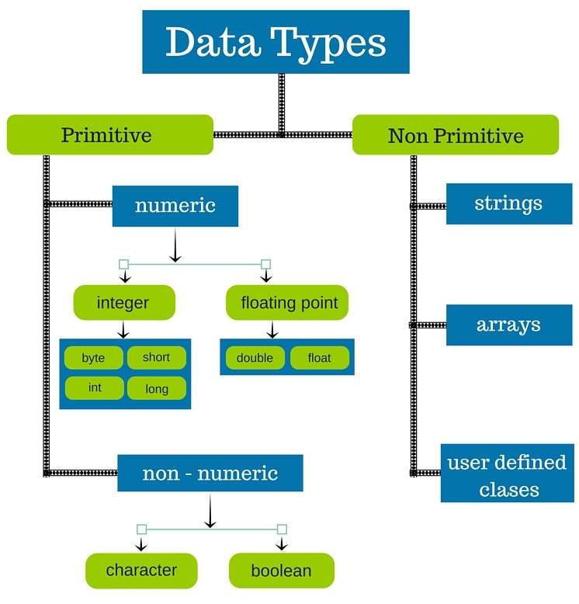

### **byte**

* Minimum value is -128 (-2^7)
* Maximum value is 127 (inclusive)(2^7 -1)
* Default value is 0
* Byte data type is used to save space in large arrays, mainly in place of integers, since a byte is four times smaller than an integer.
* Example: byte a = 100, byte b = -50

### **short**

* Minimum value is -32,768 (-2^15)
* Maximum value is 32,767 (inclusive) (2^15 -1)
* Short data type can also be used to save memory as byte data type. A short is 2 times smaller than an integer
* Default value is 0.
* Example: short s = 10000, short r = -20000

### **int**

* Minimum value is - 2,147,483,648 (-2^31)
* Maximum value is 2,147,483,647(inclusive) (2^31 -1)
* Integer is generally used as the default data type for integral values unless there is a concern about memory.
* The default value is 0
* Example: int a = 100000, int b = -200000

### **long**

* Minimum value is -9,223,372,036,854,775,808(-2^63)
* Maximum value is 9,223,372,036,854,775,807 (inclusive)(2^63 -1)
* This type is used when a wider range than int is needed
* Default value is 0L
* Example: long a = 100000L, long b = -200000L

### **float**

* Float is mainly used to save memory in large arrays of floating point numbers
* Default value is 0.0f
* Example: float f1 = 234.5f

### **double**

* This data type is generally used as the default data type for decimal values, generally the default choice
* Default value is 0.0d
* Example: double d1 = 123.4

### **boolean**

* boolean data type represents one bit of information
* There are only two possible values: true and false
* This data type is used for simple flags that track true/false conditions
* Default value is false
* Example: boolean one = true

### **char**

* Char data type is used to store any character
* Example: char letterA = 'A'

**What are Java Modifiers and there access properties?**

Access Modifiers in Java. Access modifiers are keywords in Java that are used to set accessibility. An access modifier restricts the access of a class, constructor, data member and method in another class. Java language has four access modifier to control access level for classes and its members.

We have Access Modifiers which controls the access level as discussed above and below is the pictorial representation for the same.

We also have Non Access Modifiers which are listed below:

* ABSTRACT
* FINAL
* STATIC

These concepts can be covered ahead.

**What are Java Operators?**

Java divides the operators into the following groups:

* Arithmetic operators
* Assignment operators
* Comparison operators
* Logical operators

Arithmetic Operators

|  |  |  |  |  |
| --- | --- | --- | --- | --- |
| **Operator** | **Name** | **Description** | **Example** | **Try it** |
| + | Addition | Adds together two values | x + y | [Try it »](https://www.w3schools.com/java/tryjava.asp?filename=demo_oper_add) |
| - | Subtraction | Subtracts one value from another | x - y | [Try it »](https://www.w3schools.com/java/tryjava.asp?filename=demo_oper_sub) |
| * | Multiplication | Multiplies two values | x * y | [Try it »](https://www.w3schools.com/java/tryjava.asp?filename=demo_oper_mult) |
| / | Division | Divides one value by another | x / y | [Try it »](https://www.w3schools.com/java/tryjava.asp?filename=demo_oper_div) |

Multiple Inheritance